Deploying Jenkins

1. Created a VPC

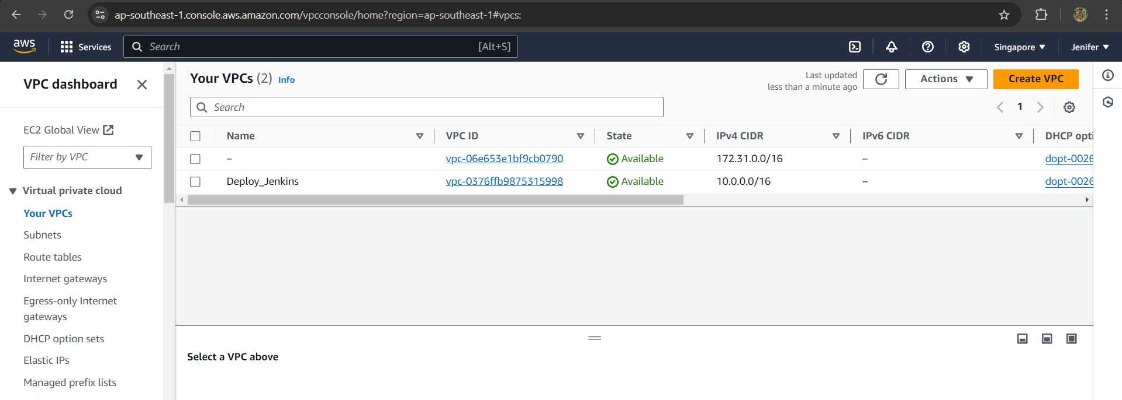

1. Created Public & Private Subnets

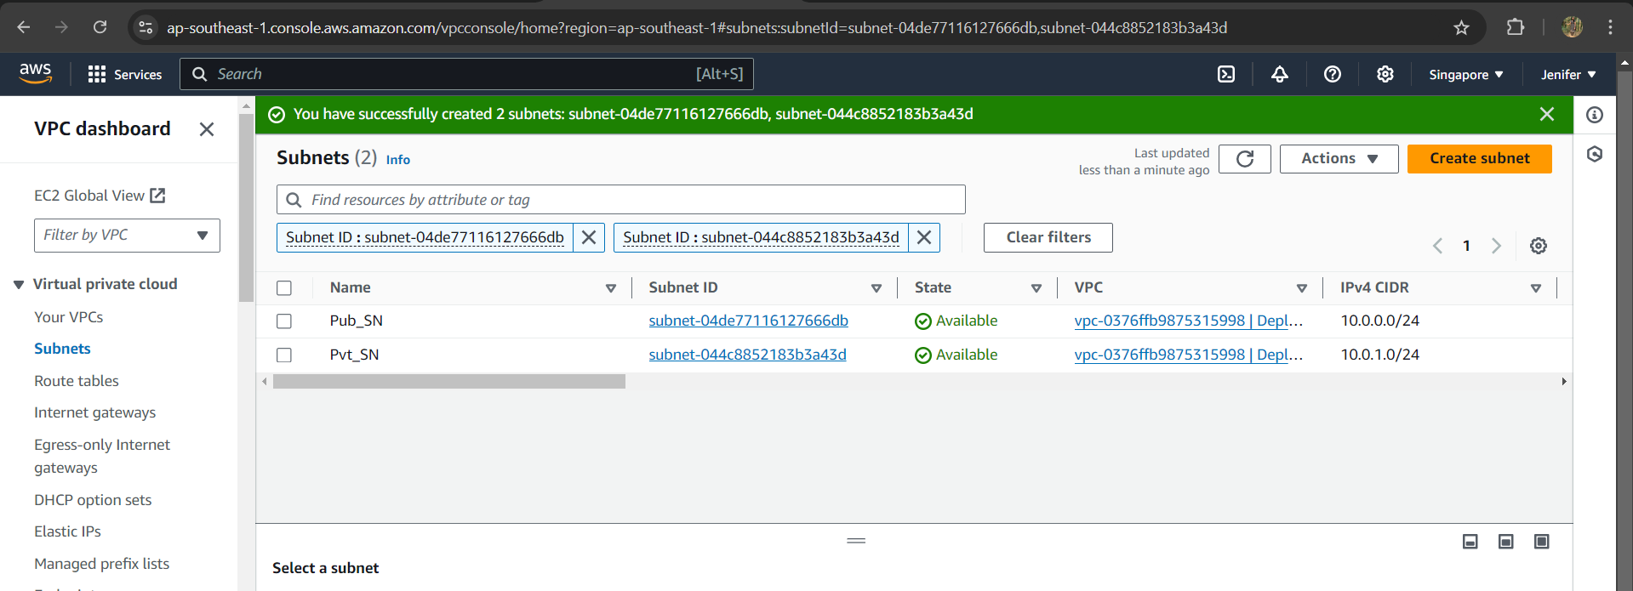

1. Created Route Table and Associted the Subnets to the Route Table

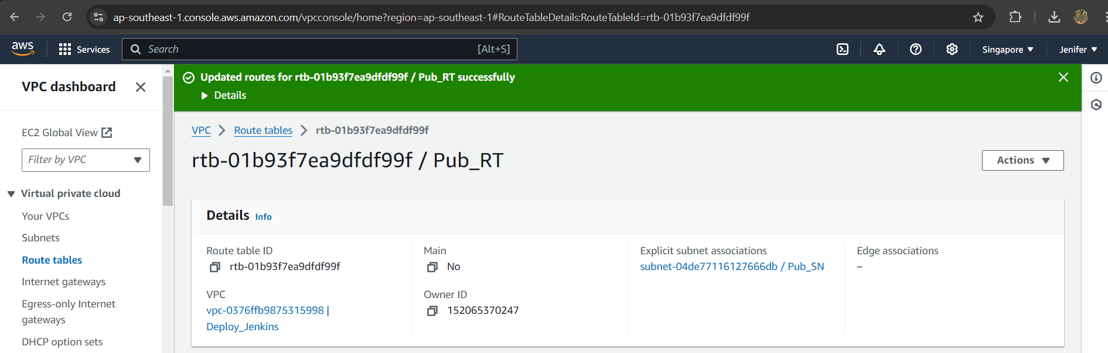

1. Created Internet Gateway and Attached to the VPC

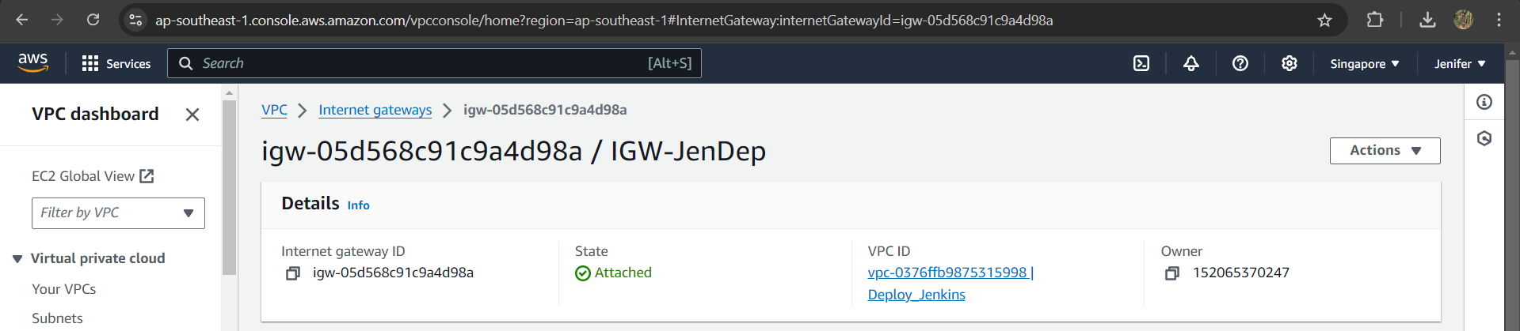

1. Launched the Instance (Ubuntu Server)

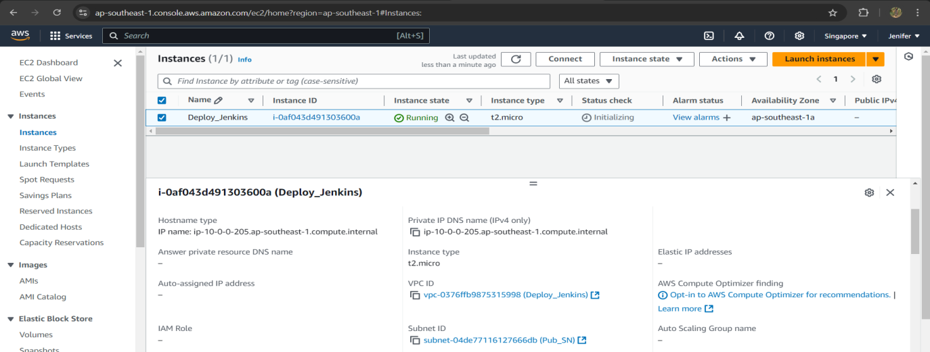

1. Deployed Jenkins on the server

